ST. ANDREW’S UNITED CHURCH

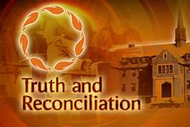

60 West Avenue, St. Thomas 519 631-4558
e-mail: standrewsucgra@rogers.com
website: www.standrewsunitedchurch.com
Ministers: The people of St. Andrew’s
Pastor: Rev.Cheryl Bolton
Ministry of Music: Lynn Sloan

September 26, 2021

WE GATHER

WE LISTEN FOR GOD’S WORD

RESPOND TO GOD’S WORD

Announcements
Next Sunday, October 3rd 2021 will be the date of our annual meeting, following church that day! It will be a short meeting.
Please check the hall for a Coffee sign up list, to help with Fellowship time after Sunday Service.

