St.Andrews
United Church



Ministers: The people of St. Andrews
Web site: www.standrewsunitedchurch.com
Minister of the People: Rev. Cheryl Bolton
Ministry of Music: Merna Edison
October 25th, 2026
Reformation Sunday

WE GATHER

Welcome & Announcements
Lighting the Christ Candle
Acknowledging Our Kinship

Call to Worship
God is our dwelling place from year to year, age to age.
And yet, we become complacent, forgetting who we are.
God reforms us
and makes prosperous the work of our hands!
God’s life surges forth through creation, like grass that renews every morning.
And yet we prefer to be dust, swept away in the wind of every new idea and new fad.
God reforms us
and makes prosperous the work of our hands!
God turns to us, and has compassion on us,
so the great work of our lives manifests Christ’s glorious love to the world.
God reforms us
and makes prosperous the work of our hands!

Gathering Hymn - A Mighty Fortress is Our God - 262 VU

Prayer of Confession - Unison
Living God, you are always creating, renewing, and calling us forward. Yet we confess that we often resist change, cling to familiar ways, and allow fear and doubt to hold us back.
We have not always loved as you call us to love, nor lived with the courage and generosity of Christ.
* (A moment of silence)*
Forgive us, O God. Renew our hearts, strengthen our faith, and reform us through your Spirit, that we may follow Christ with hope and courage. Amen.
Words of Assurance

Young at Heart - Are We There Yet?
Hymn - I Have Called You By Your Name - 161 MV

LISTEN FOR GOD’S WORD
Prayer of Illumination
Scripture Reading - Deuteronomy 34:1–12
Ministry of Music
Meditation - Standing on the Edge of Something New
Hymn - We Are Pilgrims - 595 VU
WE RESPOND TO GOD’S WORD

Invitation to Offering
Offering Hymn - For the Gift of Creation - 538 VU
For the gift of creation, the gift of your love,
and the gift of the Spirit by which we live,
we thank you and give you the fruit of our hands.
May your grace be proclaimed by the gifts that we give.

Dedication

Prayer of Thanksgiving and Concern
Lord’s Prayer

Hymn - Guide Me, O Thou Great Jehovah - 651 VU

Commissioning and Benediction
Three Fold Amen
Announcements
Upcoming
- Exercise Class M,W,F-mornings
- STYC-Tuesday Evening
- Lunch Bunch Choir-hall, Wednesday afternoon
- Line Dancing-Wednesday Evening 6pm
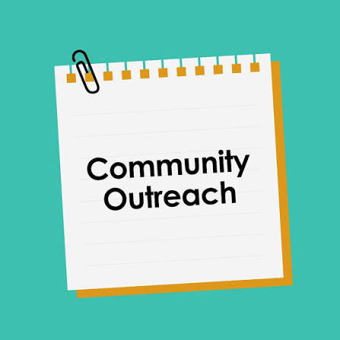
- Knitting- 10am at NVCC on Wednesday
Community Outreach Dinner on November 20th, at St.Thomas Anglican Church. Free. All are welcome. Doors open at 4:30pm and meal is from 5pm-6:30pm.

We here at St. Andrews United church would like to take moment, and Thank Connie Parsons who has been volunteering with the Community Dinners over the last few years! Connie will diligently search out things needed for the dinners. (Often finding a great bargain!) Thanks, Connie, for all your hard work.

The UCW will be sending out Christmas Cards this year. If you know of someone who is perhaps unable to get to church on a regular basis, and could use a bit of Christmas Cheer, please let Susan in the office know. She will get the information to the UCW.


Another Thank you goes out to Belinda Bainbridge who does so much with the monthly UCW donation program. Belinda counts, and sort, and delivers often. Thank you, Belinda, for your time and all your hard work. A thank you goes out the ladies that help Belinda with this. As well, thanks you to both congregations for your continued support and generosity! It truly is amazing.

