St. Andrews United Church

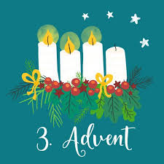

Web site: www.standrewsunitedchurch.com
Ministers: The people of St. Andrews
The people of New Vision Community Church
Pastor: Rev. Cheryl Bolton
Ministry of Music: Merna Edison
December 14 2025
Advent 3 - Joy

Welcome and Announcement

Advent Candle Lighting
One: Today is the third Sunday of Advent,
a day when the colour shifts,the music brightens,
and we lean forward with Joy.
All: We look forward with joy.
One: Joy is not the same as cheerfulness.
Joy is deeper—a well that remains even in hard seasons, a gift that grows when shared.
All: We look forward with joy,
knowing that God delights in us
and calls us to be people of good news.
One: As this candle shines brightly,
may joy take root in our spirits,
lifting our hearts and guiding us toward
the celebration that is coming.
All: Come, Emmanuel.
Fill us with your joy.

Introit - Kindle a Flame - 19 VU

Acknowledging our Kinship

Call To Worship
One: The desert shall rejoice and blossom.
All: Joy is breaking forth!
One: The weak will be strengthened; the fearful encouraged.
All: Joy is rising among us!
One: God is coming to restore, to renew, to make all things whole.
All: We come with glad hearts, walking the holy way.
One: Let us worship God with joy!
All: Amen.

Gathering Hymn - Joyful, Joyful We Adore you - 232 VU

Prayer of Confession
Loving God, sometimes we forget to look for joy.
We get busy, we get tired,
we worry about what we do not have.
We forget that You can use
even the simplest gifts—
a drum, a smile, a helping hand,
a kind word. Forgive us.
Fill our hearts with Your joy
so we can share it with others
in this Advent season and always.
Amen.
Young at Heart - Little Drummer Boy
Hymn - Hope is a Star - 7VU
Scripture Reading - Isaiah 35: 1-10, Matthew 11: 2-11
Ministry of Music

Meditation - “When Joy Blooms in Unexpected Places”

Hymn - Be Still, My Soul – 652 VU

Invitation to Offering

Offering Hymn - In the Bleak MidWinter VU55

What can I give him, poor as I am?
If I were a shepherd, I would bring a lamb;
if I were a wise man, I would do my part;
yet what I can I give him — give my heart.

Offering Prayer

Prayers of the People

Lord’s Prayer

Hymn - Go Tell it on the Mountain VU 43

Blessing
Announcements
Upcoming
-Prayer Shawl 10:30am
-December 17-Bible Study at NVCC at 1pm
-December 18-Euchre at 1pm
-December 21 ADVENT 4

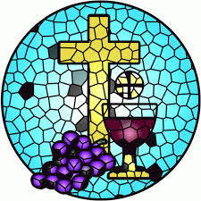
Next Sunday December 21- come celebrate the 4th Sunday of Advent and God’s love for us with communion.
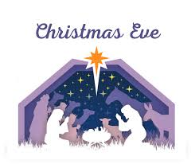
Christmas Eve service at NV at 7:00 p.m.


Dec. 28th - Cookies and Carols at respective churches. Bring your leftover cookies and enjoy coffee and cookies while we sing Christmas carols and readings.

Advent Bible Study will be at New Vision on December 17th at 1pm. All are welcome!
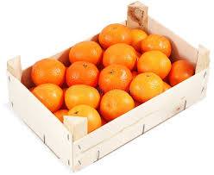
It’s a good time of year to remember to save and collect the wooden crates that oranges/clementines come in. The day camp in summer uses them for a project. You are welcome to drop them off to the office.


Community UCW Support
December- our food bank needs help. We will be collecting food each Sunday to help them. Please Bring what you can.
