St. Andrews United
Church

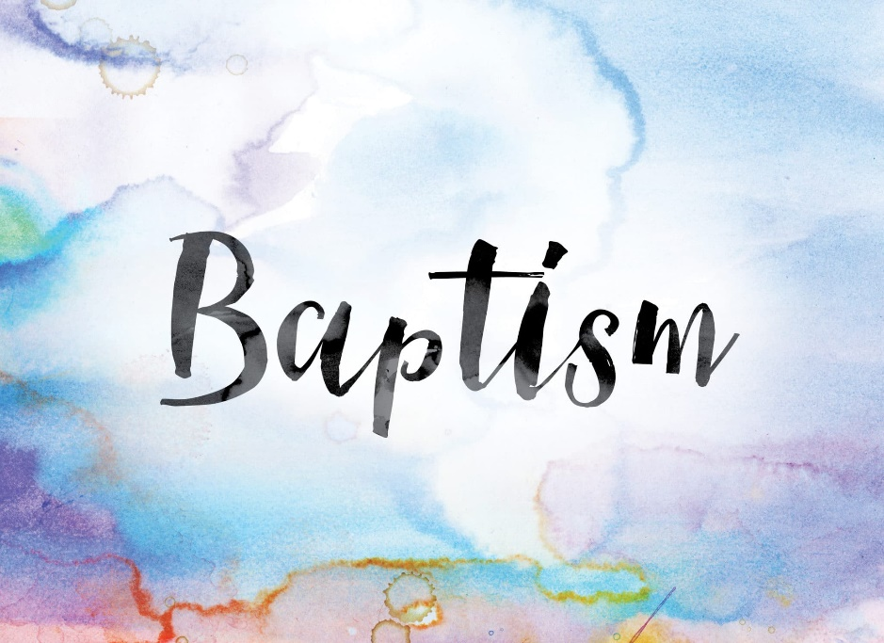

60 West Avenue, St. Thomas 519- 631-4558
e-mail: standrewsucgra@rogers.com
Website: www.standrewsunitedchurch.com
Ministers: The people of St. Andrew’s
Pastor: Rev. Cheryl Bolton
Ministry of Music: Brian and Lynn Sloan/
Merna Edison/Thomas Bee

April 7, 2024 - 2nd Sunday of Easter
We Celebrate the Sacrament of Holy Baptism

WE GATHER

Welcome & Announcements
Acknowledging Our Kinship
Candle Lighting

Call To Worship
One: We are people of the twenty-first century,
far removed from the upper room
All: “Blessed are those who have not seen
and yet have come to believe.”
One: We have put away the festive trumpets,
the fancy clothes, the chocolate bunnies of Easter Sunday.
Must the message of Easter be put away for another year?
All: “Blessed are those who have not seen
and yet have come to believe.”
One: We still seek the One who offers victory over death,
whose love conquers evil.
All: “Blessed are those who have not seen
and yet have come to believe.”
One: We gather to worship the risen Christ,
who offers us new life.
All: “Blessed are those who have not seen
and yet have come to believe.”

Gathering Hymn - I was There to Hear Your Borning Cry - 644

Prayer of Confession -
Words of Assurance (1 John 1–2)

Celebrating Holy Baptism of James Edward Felton
(Please see insert)
Presentation and Introduction
Congregational Commitment
Profession of Faith
Prayer of Thanksgiving and Pouring of the Water
The Baptism
Welcome
Prayer and Blessing

Hymn - Jesus Loves Me VU 365
WE LISTEN FOR GOD’S WORD

Scripture Reading - John 20: 19-31
Meditation - The Road Beyond Easter
Hymn - Amazing Grace VU 266

RESPOND TO GOD’S WORD
Invitation to Offering -

Offering Hymn - Grant Us, God, the Grace of Giving - 540 VU
Grant us, God, the grace of giving,
with a spirit large and free,
that ourselves and all our living
we may offer faithfully.

Offering Prayer -
Prayers of Thanksgiving and Concern
The Lord’s Prayer
Closing Hymn - One More Step Along the World - 639 VU

Commissioning and Benediction -
Lord of mercy, be with us as we go from this place today. Fill our lives with your love. Help us to bring the good news of hope and peace wherever we go. Let us truly be Easter people! AMEN.

Announcements

Upcoming
April 8- yard Sale drop off begins
April 9-UCW meets 10:30am
April 11-Board Meeting at 10:30am
April 14- STYC Performs during worship service
There will be an Inside yard Sale on April 20th run by UCW. Donations will be accepted but not until April 8 as space is limited! So start your spring cleaning and get your items ready for the Yard Sale.

If you are visiting with us for worship today, please sign our guestbook at the entrance to the sanctuary. Please join us for a time of refreshment and fellowship following the service.

