St.Andrews United Church

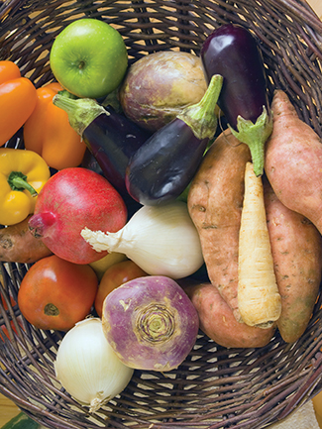

60 West Avenue, St. Thomas 519- 631-4558
e-mail: standrewsucgra@rogers.com
Website: www.standrewsunitedchurch.com
Ministers: The people of St. Andrew’s
Pastor: Rev. Matthew Penny
Ministry of Music: Brian and Lynn Sloan/
Merna Edison/Thomas Bee
September 17th 2023

WE GATHER

Welcome & Announcements

Acknowledging Our Kinship

Candle Lighting
One: This is the light of one candle. Christ said one little light could push back a lot of darkness.
All: This is a candle of hope. We pray for the world that the light of Christ will be seen.

Gathering Hymn: Come, Let Us Sing of a Wonderful Love VU574

Call To Worship
One: God breathed life into human beings made in God’s image.
All: We remember. So let’s give God the glory!
One: God called to a runaway shepherd, Moses, to lead God’s people out of slavery.
All: We remember. So let’s give God the glory!
One: God, like a pillar of clouds, led the people through the sea to freedom.
All: We remember. So let’s give God the glory!
One: God caused a rock in the wilderness to flow like a river.
All: We remember. So let’s give God the glory!
One: God gives us a way when there seems no way.
All: We remember. So we worship today.
One: Let us Pray...

Hymn – Your Hand O God, Has Guided VU274

Prayer of Approach and Confession

Young at Heart

LISTEN FOR GOD’S WORD
Scripture Reading – Exodus 16:2-15 Rebellion in the desert

Meditation – God Gives to the People.

Hymn – We Praise You for the Sun VU 225

RESPOND TO GOD’S WORD

Invitation to Offering
Offering Hymn - Praise God from Whom All Blessing Flow - 541 VU
Praise God from whom all blessings flow;
praise God, all creatures high and low;
give thanks to God in love made known:
Creator, Word and Spirit, One.

Offering Prayer

A Minute for Celebrations and Concerns
Prayers of Thanksgiving and Concern
The Lord’s Prayer

Hymn – Creating God Your Fingers Trace VU 265

Benediction.
One: We have been fed by the stories of faith.
All: We turn our faces into the uncertain places so we may know God.
One: We have been sustained in the rituals of community.
All: We turn our lives back to the God of plenty.
One: May the God of bread and justice accompany us.
All: May the Spirit surround us with hope as we walk the way of the Christ.

Please Note on September 24th there will be an important Congregational Meeting to discuss a Collaborative Ministry with New Vision United Church. Please plan to attend this special meeting.

Announcements

UPCOMING EVENTS:
September 20th – Prayer Shawl 10:30am
September 28th-Euchre 1:30pm

October 19th
The “Bean Blast” is back! This fundraiser is from 11:30-1pm at St. Anne’s Centre on October 19th. Tickets are $10 and Connie Parsons will have tickets.

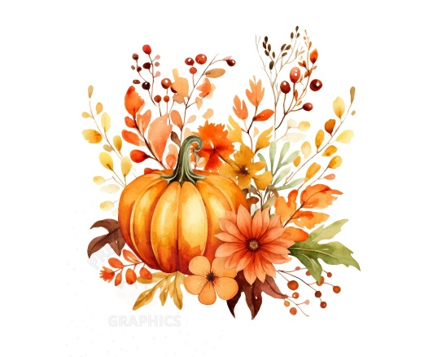
Spread the Word! It’s Time to Celebrate
Lexi Li’s 30th birthday.
Please join us on September 30th from 2-4pm for an open house! We will celebrate with some coffee, tea and goodies. Let your presence be your gift!
All are welcome!
Address: 60 West Ave. St.Thomas ON
Time: 2pm-4pm (Drop in anytime!)
Date: September 30th, 2023
Call Susan at 519-859-7142 if more details are needed
SHHHHHHHHHHHHHHHHHHH…don’t tell Lexi! It’s a surprise!

