St. Andrews United Church
and
New Vision Community Church
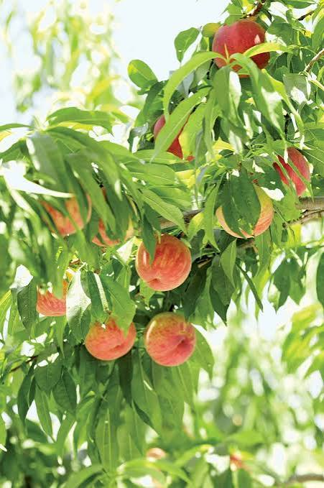

Ministers: The people of St. Andrews and New Vision
Minister of the People: Rev. Cheryl Bolton
Ministry of Music: Merna Edison
July 26th, 2026
9th Sunday After Pentecost
WE GATHER

Welcome & Announcements
Grace to you and peace from God our Father and the Lord Jesus Christ.
Today we gather to hear Jesus' parables about the Kingdom of Heaven. Through simple stories of mustard seeds, yeast, hidden treasure, pearls, and fishing nets, Jesus reminds us that God's kingdom often begins in small and unexpected ways, yet it grows beyond imagination. It is a kingdom of immeasurable value—a gift worth giving everything to receive.

Candle Lighting
One: Today we light this candle as a sign of God's presence among us.
God's love is like a candle, bringing light into every darkness.
Its light grows brighter as it is shared with others.
May God's light transform us from the inside out.
As we light this candle, may its flame remind us that Christ, the Light of the World, is with us always.
May God's love shine in us, through us, and beyond us, so that others may see the hope, peace, joy, and love of Christ.

All:
Loving God, kindle within us the flame of your love. Let it burn brightly in our hearts, guide our steps, warm our spirits, and inspire us to share your light with all we meet. Through Jesus Christ our Lord. Amen.
Acknowledging Our Kinship
Long before settlers came to this land, Indigenous peoples lived here,
caring for creation and honouring the Creator.
We honour their wisdom, their resilience, and their ongoing presence.
May we walk together in respect, justice, and reconciliation.

Call to Worship
Leader: The kingdom of heaven is like a mustard seed.
People: Though it begins small, God brings great things from it.
Leader: The kingdom of heaven is like yeast hidden in flour.
People: God's love transforms everything it touches.
Leader: The kingdom is like treasure hidden in a field.
People: Nothing compares to the joy of finding God's grace.
Leader: Come, let us worship the King whose kingdom has no end.
People: We come with joyful hearts to worship God!

Gathering Hymn - Seek Ye First - 356 VU

Prayer of Confession
Merciful God, too often we have looked for greatness while overlooking the small beginnings of your work. We have valued earthly success more than the treasures of your kingdom.
We have held tightly to possessions, pride, and comfort instead of trusting you completely.
Forgive us. Renew our hearts.
Teach us to seek first your kingdom and your righteousness.
Help us become faithful servants who joyfully share your love with others. Through Christ our Lord.
Amen.

Assurance of Grace
Hear the Good News:
The treasure of God's kingdom is not earned but freely given through Jesus Christ. In him we are forgiven, restored, and made new.
Thanks be to God!

Young at Heart - God is Like…

Hymn - We Are Marching - 646 VU

WE LISTEN FOR GOD’S WORD

Scripture Reading - Matthew 13:31–33, 44–52

Ministry of Music

Meditation - Treasure Hidden in Plain Sight

Hymn - God Who Gives to Life Its Goodness - 260 VU

RESPOND TO GOD’S WORD

Invitation to Offering
Jesus reminds us that the Kingdom is the greatest treasure we could ever receive.
As grateful people, we now offer our gifts, trusting God to use them for the growth of God's Kingdom throughout the world.

Offering Hymn - What Can I Do? MV 191
What can I do? What can I bring?
What can I say? What can I sing?
I'll sing with joy. I'll say a prayer.
I'll bring my love. I'll do my share."

Offering Prayer - Lord, Receive these gifts and our lives.
Use them to spread your love, grow your Church, and proclaim the good news of your Kingdom. In Jesus' name. Amen.

Prayers of Thanksgiving and Concern
Lord, we give you thanks for the word that you hide like a treasure in our heart, for the leaven which is able to penetrate to every area of our life - for the seed that is able to grow into a mighty plant. Help us to value that which you have given us - to make following Christ the most important thing in our daily lives - to concentrate above all upon doing your will and sharing your love and the good news you have proclaimed through Jesus with one another and with the world.

We give you thanks for the wonders of our heritage and for the new things that you continue to do in our midst. We praise you for the teachings of the prophets, for the law you revealed unto Moses, for the grace and the love that you poured out and continue to pour out through Christ - and for the guidance, the strength, the wisdom, the peace, the joy, the patience, and the gentleness that you bestow upon us through your Spirit. Help us to value both the old and the new and to become worthy teachers of the lessons of your eternal kingdom.
We pray for the people around us this day - for those who are upon our hearts and minds because of a need that they have…

(Silence)

Bless each one according to the need that they have and bring all to a closer walk with you.
We ask you to hear all our prayers, O God, in the name of the one who taught us to pray… OUR FATHER....

The Lord’s Prayer

Closing Hymn - In the Quiet Curve of Evening - 278 VU

Commissioning and Benediction
Go now as citizens of God's Kingdom.
Plant seeds of hope.
Share the treasure of Christ.
Trust God to bring growth where you cannot.
May the grace of our Lord Jesus Christ,
the love of God,
and the fellowship of the Holy Spirit
be with you now and always.
Amen.

Choral Amen

ANNOUNCEMENTS

August donations are going to John Wise Public School. They are Needing: dry erase markers, chubby short markers, pencils, rulers and calculators.


St. Andrews United Church will be closed for the month of August and will be joining NVCC. Service will start at 9:45am!!


Come and meet Baby Kaia (daughter of Lindsay and David) and welcome the DeMoor family visiting from out west!
On Sunday July 26th from 1pm-3pm, at St.Andrews United Church 60 West Ave in St.Thomas. Come and enjoy some light refreshments. Hosted by Lynn Sloan and Tevia Ostrosser

