St. Andrews United Church
and
New Vision Community Church
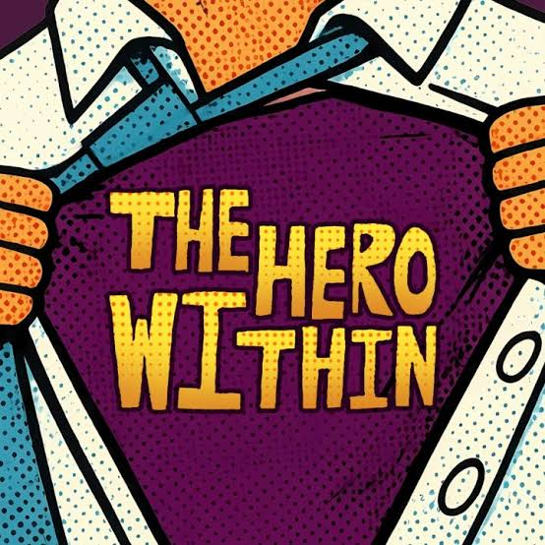
Ministers: The people of St. Andrews and New Vision
Minister of the People: Rev. Cheryl Bolton
Ministry of Music: Rob Earnshaw
August 30th, 2026
Finding the Hero Within
WE GATHER

Welcome & Announcements
Welcome to worship on this final Sunday of our Superhero series!
Over these past weeks, we have met some rather unlikely superheroes. We have discovered that superheroes aren't only found in comic books or on movie screens. Sometimes they are found in scripture. Sometimes they are found in our communities. And sometimes—perhaps more often than we realize—they are sitting right beside us.
Today we turn the question around.
Instead of asking, “Who are the superheroes?” we ask, “What superpowers has God given me? What gifts has God given us? And what are we going to do with them?”
Because different does not mean less.
Smaller does not mean useless.
Older does not mean finished.
God is still calling.
So let us listen, discern, and discover what God might be calling us to do next.

Candle Lighting
We light this candle as a reminder that the light of Christ is among us.
One candle may seem like a small thing.
But one candle can break the darkness.
One act of kindness can change a day.
One listening ear can ease a burden.
One courageous voice can challenge an injustice.
One willing person can make a difference.
May this light remind us never to underestimate what God can do with what we are willing to offer.

Acknowledging Our Kinship
As we gather, we acknowledge that we worship on land that has been cared for by Indigenous peoples since long before our churches or communities took their present form.
We give thanks for the generations who have walked this land before us, for those who share it with us today, and for those who will inherit it after us.
Acknowledging our kinship means more than remembering history. It asks us to consider the relationships we are building today.
May we learn to listen with humility, seek truth with courage, repair relationships where harm has been done, and live as good relatives—with one another, with our Indigenous neighbours, with creation, and with all God's children.

Call to Worship
One: God does not ask us to be who we once were.
All: God calls us to be faithful where we are.
One: God does not ask us to have someone else's gifts.
All: God asks us to use what we have been given.
One: We may feel too small, too tired, or too ordinary.
All: But God is not finished with us.
One: The Spirit is still moving.
All: We will listen.
One: God is still calling.
All: We will discern.
One: There is still love to give and good to do.
All: With God's help, we will act.
One: Come, people of God. Let us worship together.

Gathering Hymn - Come, Let Us Sing - 574 VU

Prayer of Confession
God of every age and every season,
sometimes we look backward and remember what used to be.
We remember fuller pews, busier Sunday schools,
larger choirs, more volunteers, more programs, more energy.
And sometimes remembering what was makes it difficult to see what is.
Forgive us when we confuse “different” with “less.”
Forgive us when we decide that because we cannot do everything, there is nothing we can do.
Forgive us when we compare ourselves with others, or even with earlier versions of ourselves, and fail to recognize the gifts you have placed in our hands today.
Forgive us when fear speaks louder than your Spirit.
Open our eyes to what remains.
Open our hearts to new possibilities.
Open our ears to your call.
Give us courage to release what no longer fits, wisdom to hold fast to what is good, and faith to offer what we have.
Remind us, gracious God, that you are not finished with us yet.
Amen.

Young at Heart - A Walk Down Memory Lane

Hymn - Don’t Be Afraid - 90 MV

LISTEN FOR GOD’S WORD

Scripture Reading - 1 Samuel 17:38-50 & 1 Thessalonians 5:16-23

Ministry of Music
Meditation - Finding the Hero Within
Hymn - Be Thou My Vision - 642 VU

RESPOND TO GOD’S WORD

Invitation to Offering
“What can I do?”
That is the question we are about to sing.
It is also the question at the heart of our worship today.
We may not be able to do everything.
God has never asked us to.
But we can offer something.
Our time. Our abilities. Our compassion.
Our resources. Our prayers. Our presence.
And so, with gratitude for all that God has placed in our hands, let us offer what we can.

Offering Hymn - What Can I Do? MV 191
What can I do? What can I bring?
What can I say? What can I sing?
I'll sing with joy. I'll say a prayer.
I'll bring my love. I'll do my share."

Offering Prayer
Generous God,
everything we have begins with you.
Receive these gifts and receive us with them.
Take what we offer—our money, our time, our experience, our abilities, our compassion, and our willingness—and use them in ways we may never imagine.
Give us wisdom to recognize what we can do, courage to begin, and faith to trust that small acts offered in love can make a difference.
Amen.

Prayers of Thanksgiving and Concern
God of yesterday, today, and tomorrow,
we thank you for the road that has brought us here.
We give thanks for those who built these congregations, for teachers and ministers, musicians and caretakers, cooks and committee members, Sunday school leaders and youth leaders, visitors and volunteers, and countless faithful people whose names may no longer be remembered but whose love still shapes this community.
We give thanks for what has been.
And we give thanks for what is.
For the people gathered here today.
For gifts still being shared.
For friendships still being formed.
For worship and laughter.
For meals and conversations.
For phone calls, visits, prayers, and quiet acts of kindness that may never appear in an annual report but matter deeply in someone's life.
And we give thanks for what is still possible.
When we are tempted to believe that our best days are behind us, stir our imagination.
When we become afraid of change, give us courage.
When we become tired, give us companions.
When we feel that what we have to offer is too small to matter, remind us of David's stones.
Teach us to notice the gifts around us and within us.
We pray for those who need those gifts today.
For those who are ill or recovering...
For those who are grieving...
For those who are lonely...
For those living with anxiety, depression, or despair...
For families struggling to make ends meet...
For people frightened by what tomorrow may bring...
For communities torn by violence, injustice, hatred, or war...
For the earth and all creatures with whom we share this fragile home...
And in the silence, we name those people and situations particularly upon our hearts.
Silence.
Holy Spirit, do not let us become so overwhelmed by everything that is wrong that we fail to do the good that is ours to do.
Show us where love is needed.
Show us what is in our hands.
And when you call—
give us courage to answer.
We gather these prayers, spoken and unspoken, in the prayer Jesus taught his friends to pray:

The Lord’s Prayer

Closing Hymn - Go Forth for God - 418 VU

Commissioning and Benediction
Before you go, remember:
You don't need someone else's armour.
You don't need someone else's gifts.
You don't need to be the person you were twenty years ago.
You need only to be the person God is calling you to be now.
So take what God has placed in your hands.
Take your experience. Take your wisdom.
Take your compassion.
Take your voice. Take your story. Take your faith.
Listen for the Spirit.
Discern what is good.
And then act.
For different does not mean less.
Smaller does not mean useless.
God is still calling.
And may the grace of Jesus Christ,
the love of God,
and the presence and power of the Holy Spirit
go with you as you discover—and use—the gifts God has given you.
Amen.

Choral Amen

ANNOUNCEMENTS

The New Vision Board is seeking a Board secretary to take minutes during our meetings and distribute them to Board members. If you are interested or have questions please contact either Board Chair - Mark Shields or Rev. Cheryl.


September Donations
September donations will be going to John Wise Public School. The school has requested donations of clothing items, specifically jogging pants and underwear. Children often get wet while playing outside, so having extra clothing available for them to change into is incredibly helpful.
Jogging Pants
- Neutral colours are preferred, such as grey, black, navy, etc.
- Children’s sizes are the main focus.
Underwear
  - Both boys’ and girls’ underwear are welcome.
  - All sizes are appreciated.
Thank you for helping provide these practical items to students who may need them!


New Vision is looking for 2 people weekly to donation a treat, cookies, loaves, squares, goodies etc. for the after-church fellowship time. They should be on your own plate so after use you can take the plate back home. A sign-up sheet will be available at the kitchen window. Any questions just call Jean Taylor at 519 631 9125.


Disking will be starting again at New Vision. On September 2, the group meets every Wednesday from 2-4pm. All are welcome, snacks are provided, and the group asks for a donation of .25cents every week
which goes to a charity at year end. Info: Nell Beckett at 519-631-2554


St. Andrews United Church will be having a Drive Thru pulled turkey supper on September 25th. Cost will be $15. More information will be coming next week, but reserve on your calendars!

