St. Andrews United

Church

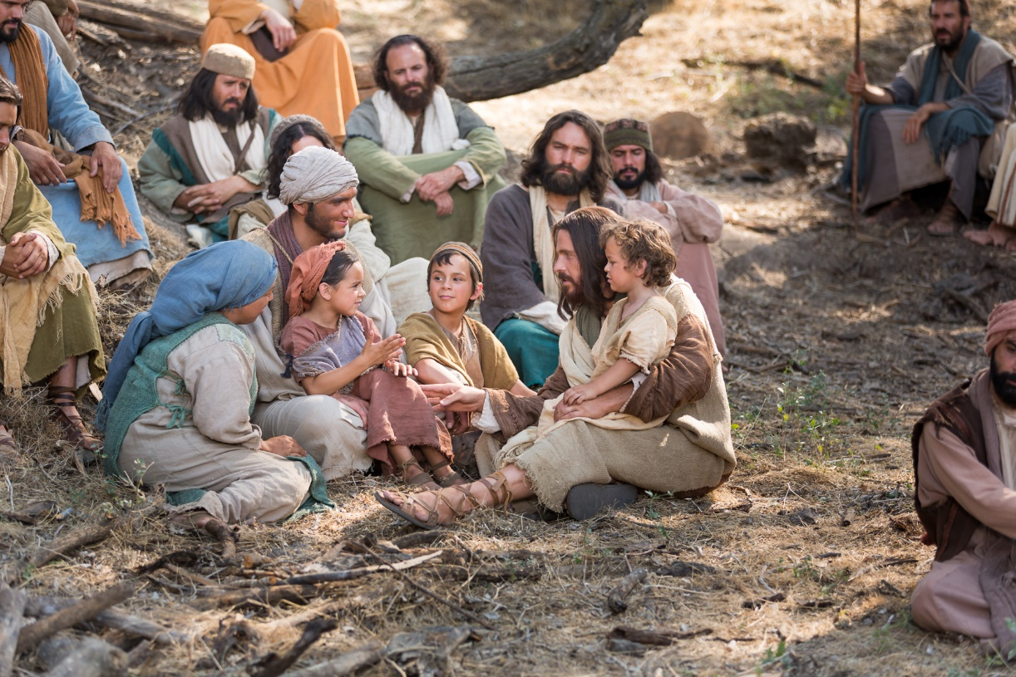

60 West Avenue, St. Thomas 519-631-4558

e-mail: [standrewsucgra@rogers.com](mailto:standrewsucgra@rogers.com)

Website: [www.standrewsunitedchurch.com](http://www.standrewsunitedchurch.com/)

Ministers: The people of St. Andrew’s

Pastor: Rev. Cheryl Bolton and Rev. Matthew Penny

Ministry of Music: Brian and Lynn Sloan/

Merna Edison/Thomas Bee

May 26, 2024

**WE GATHER**

**Welcome & Announcements**

**Acknowledging Our Kinship**

**Candle Lighting**

**Call To Worship**

**One:** As we gather today

**All: we listen for the voice of God**

**One**: in our innermost being.

**All: We listen for the voice of God**

**One:** in the words we read, the songs we sing, the prayers

we pray.

**All: We listen for the voice of God**

**One:** in words of hope and kindness.

**All: We listen for the voice of God**

**One:** in the difficult words that need to be said.

**All: As we gather, may we listen and may we hear.**

**One:** Come let us Worship.

**Gathering Hymn –** VU560 - O Master, let me Walk with Thee.

**Prayer of Confession**

**One:** Forgiving God, we confess that so often we block the idea

that you chose us to follow our own special path. We choose fear over love and bury our God-given gifts.

**All**: **Forgive us, O God send your Holy Spirit.**

**One:** We confess those times we fail to notice that others have gifts to express, yet the Body of Christ needs all of its members to flourish.

**All**: **Forgive us, O God** **and walk with us.**

**One:** We confess those times we are jealous of others and crush and obstruct their gifts, denying that they too are chosen.

**All**: **Forgive us, O God and let us be your people.**

**One:** Help us to see that the loss of our gifts withholds your light from the world and grant us the courage to live as your chosen people.

**All: Be with us O Lord, and Let us follow your Way.**

***Words of Assurance***

**Hymn –**VU415 - God, We Praise you for the Morning.

**WE LISTEN FOR GOD’S WORD**

Reflections on the word.

**Scripture Reading -**  Matthew 10:24-39 The student is not above the teacher.

**Meditation – Following Takes Determination.**

**Hymn** – VU356 - Seek Ye First the Kingdom of God.

**RESPOND TO GOD’S WORD**

**Invitation to Offering**

**Offering Hymn - Grant Us, God, the Grace of Giving - 540 VU**

Grant us, God, the grace of giving,

with a spirit large and free,

that ourselves and all our living

we may offer faithfully.

**Offering Prayer**

**Prayers of Thanksgiving and Concern**

**The Lord’s Prayer**

**Closing Hymn –** VU260 - God who gives to Life it’s Goodness.

**Commission and Benediction**

**Announcements**

Upcoming UCW events at St. Andrew's United Church

Mark your calendar for the upcoming UCW events:

* *Tuesday June 11 - UCW end of year luncheon - more details to follow on time and place - please let JoAnn Day know if you are going to attend 519-631-1561*

***Upcoming***

**May28,29-Alzheimers hall rental, 9-3pm**



**Today’s flowers are placed in memory of Gladys and Ron Payson by Marjorie Gowdey.**

**Strawberry Social is fast approaching. Come and enjoy a fantastic meal of hash brown casserole, and always strawberries for dessert. Tickets are $20 for adults and $10 for 10 and under.**

 **Our UCW has come up with a fantastic way to celebrate our Nationwide United Church 100th Anniversary. Every month we are going to collect 100 food items etc for the food bank. Each Sunday we will pick a food/hygiene product to focus on, and we hope to collect 25 items each Sunday. June 2nd is our start date and we are collecting PEANUT BUTTER that day! Come on St.Andrews..bring in your peanut butter on June 2!**