***St. Andrews United Church***

***&***

***New Vision Community Church***

***July 6, 2025***

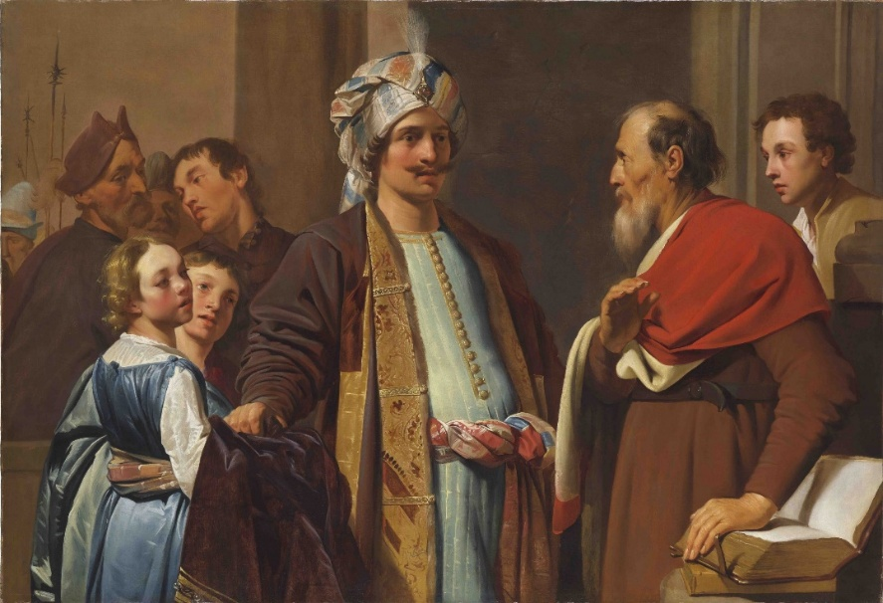

60 West Avenue, St. Thomas 519-631-4558

E-mail: [standrewsucgra@rogers.com](mailto:standrewsucgra@rogers.com)

Web site: [*www.standrewsunitedchurch.com*](http://www.standrewsunitedchurch.com)

Ministers: The people of St. Andrew’s

Pastor: Rev. Cheryl Bolton

Guest minister: Rev. Matthew Penny

Ministry of Music: Merna Edison

**WE GATHER**

**Welcome.**

**Announcements.**

**Lighting the Christ Candle.**

**Opening Prayer.**

**Acknowledging Our Kinship**

One: For many eons, the First Nations people of this area have walked this land. Their relationship with the land is central to their culture. We are on that land and in this time acknowledge their history which we now share. We hope that with a joint effort we can be reconciled one with another and live together as all God’s people.

**All: For we are all God’s people. We are one with each culture, with the earth and all that is in it. Amen.**

**Call to worship:**

One**:** God invites us to listen for God in unexpected prophets.

**All: Come and listen for God.**

One**:** God invites us to hear God’s voice in unexpected

moments.

**All: Come and hear God’s voice.**

One**:** God invites us to speak God’s name in unexpected

places.

**All: Come and speak God’s name.**

One**:** God invites us to come with God into every nook and

Cranny where the unexpected is hidden in every yet-to-be.

**All: Come, and worship God.**

**Hymn –** **VU142, Jesus Keep me near the Cross.**

**Prayer of Confession:**

One: O God, whom in our lives have we ignored?

**All: Have we ignored a child or ignored advice?**

One: Lord, we have failed to listen to those on the sidelines.

**All: We never expect the words of heaven to come from the mouths of children or the homeless.**

One: Lord, have we ignored people from other cultures?

**All: O God, forgive us for thinking we are the only ones who know the ways of the world.**

One: Open our closed Minds we pray.

**All: Open our minds to those who we see as not like us, not like we are and like we think they should be.**

One: You forgive O God; set your Spirit upon us we pray.

**All: Let your Spirit grant us peace we pray. Amen.**

**Words of Assurance:**

**Hymn – VU 216, Sing Praise to God who reigns above.**

**All God’s Children**

**Hymn –** **VU 313, God Whose Almighty Word.**

**WE LISTEN FOR GOD’S WORD**

**Scripture Reading-** 2 Kings 5:1-14

**Ministry of Music.**

**Meditation: *Expect to Be Surprised.***

**WE RESPOND TO GOD’S WORD**

**Invitation to Offering**

**Offering Hymn - For the Gift of Creation - 538 VU**

For the gift of creation, the gift of your love,

and the gift of the Spirit by which we live,

we thank you and give you the fruit of our hands.

May your grace be proclaimed by the gifts that we give.

**Dedication.**

**A Moment for Concerns and Celebrations**

**Prayers of Thanksgiving and Concern.**

**The Lord’s Prayer**

**Hymn –** **VU 415, God We praise you for the Morning.**

**Blessing and Commissioning**

**Choral Amen**

***Announcements***



**A huge thank you to all the people who prepared the lunch for after church last week. Especially to those who thought cake was a good idea – which is always is.**

**Cheryl and her family would love for you to join them at their farm for worship and a barbecue.  Please bring your lawn chairs and sunscreen.  New Vision folks please bring sides and St. Andrew’s folks please bring a dessert.  We will provide the rest.  Rain or shine!  Please remember this is a working farm, wear comfortable clothes and practical shoes.  You may wish to carpool.  
Date: August 31, 2025  
Time: 11:00 a.m  
Address: 1574 Katesville Drive, Kerwood**