***St. Andrews United Church and***

***New Vision***

***Community Church***

***July 13, 2025***

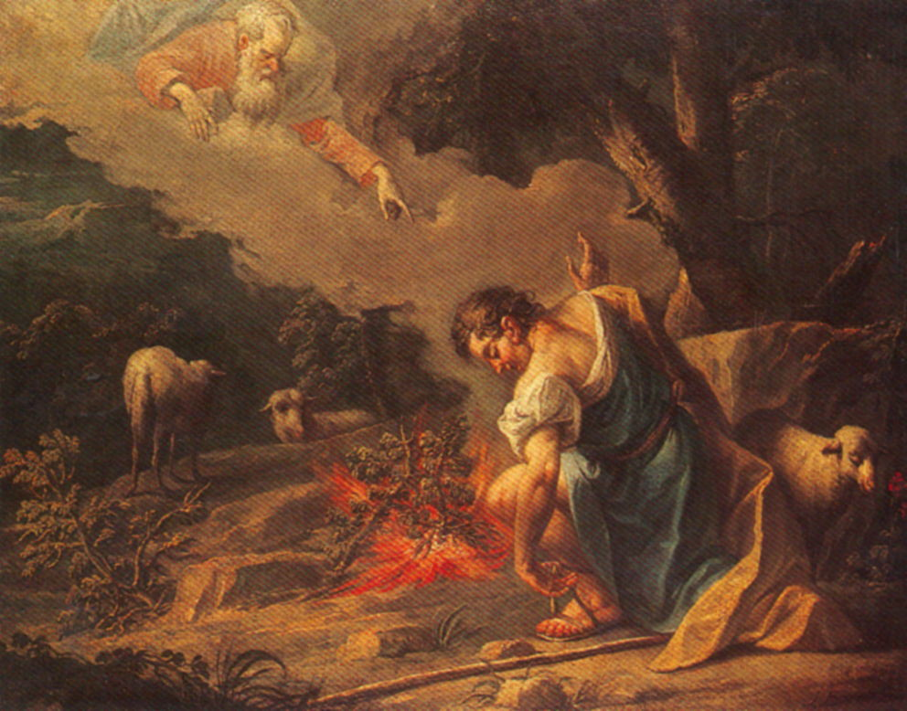

60 West Avenue, St. Thomas 519-631-4558

E-mail: [standrewsucgra@rogers.com](mailto:standrewsucgra@rogers.com)

Web site: [*www.standrewsunitedchurch.com*](http://www.standrewsunitedchurch.com)

Ministers: The people of St. Andrew’s

Pastor: Rev. Cheryl Bolton

Guest minister: Rev. Matthew Penny

Ministry of Music: Merna Edison

**WE GATHER**

**Welcome.**

**Announcements.**

**Lighting the Christ Candle.**

**Opening Prayer.**

**Acknowledging Our Kinship**

One: For thousands of years, the Indigenous people of Canada have walked this land. Their relationship with the land is central to their culture. We are on that land and in this time acknowledge their history which we now share. We hope that through partnership all people can be reconciled one with another and live together.

**All: We are all God’s people. Every culture matters. We are all one with the earth and all that is in it. Amen.**

**Call to worship:**

**One:** In the presence of the faithful, let us proclaim God’s

name.

**All:** **In the presence of the faithful, we will praise**

**your name, O God.**

**One:** In times of joy and pain:

**All:** **In the presence of the faithful, We will Give thanks to God for all that we are.**

**One:** Whether serving at table, or in the streets, or on the

mountaintops:

**All:** **In the presence of the faithful, we are God’s people and we accept that we need to be with God.**

**One:** In our learning and teaching, and all of our growing:

**All: In the presence of the faithful, in worship and praise we seek to be in the presence of God.**

**One:** Come, let us worship God.

**Hymn –** **VU 234, Let us with a Gladsome Mind.**

**Prayer of Confession:**

**One:** God of love and patience, we take this moment to pause and confess those times when we are too busy for you, for one another, and for ourselves. When we are too busy to spend time in prayer and

listen in our hearts for your word in our lives,

**All: forgive us, God.**

**One:** When we are too busy to notice the needs of others and ways in which we can be present with them,

**All: forgive us, God.**

**One:** When we are too busy to stop what we are doing and help one another, or laugh with one another, or simply notice one another,

**All: forgive us, God.**

**One:** When life becomes overwhelming, and we do not even take time for our own needs,

**All: forgive us, God.**

**One:** Help us to listen to your voice within our hearts, calling us back to center our lives with you. Amen.

**Words of Assurance.**

**Hymn – VU 357, Tell me the Stories of Jesus.**

**All God’s Children**

**Hymn –** **VU 633, Bless Now O God, the Journey.**

**WE LISTEN FOR GOD’S WORD**

**Scripture Reading-** Exodus 3:1-15.

**Meditation: What do you Hear?**

**WE RESPOND TO GOD’S WORD**

**Invitation to Offering**

**Offering Hymn - For the Gift of Creation - 538 VU**

For the gift of creation, the gift of your love,

and the gift of the Spirit by which we live,

we thank you and give you the fruit of our hands.

May your grace be proclaimed by the gifts that we give.

**Dedication.**

**A Moment for Concerns and Celebrations**

**Prayers for the Community.**

**The Lord’s Prayer**

**Hymn –** **VU 637, Jesus Savior, Pilot Me.**

**Blessing and Commissioning**

**Choral Amen**

***Announcements***

**Cheryl and her family would love for you to join them at their farm for worship and a barbecue.  Please bring your lawn chairs and sunscreen.  New Vision folks please bring sides and St. Andrew’s folks please bring a dessert.  We will provide the rest.  Rain or shine!  Please remember this is a working farm, wear comfortable clothes and practical shoes.  You may wish to carpool.  
Date: August 31, 2025  
Time: 11:00 a.m  
Address: 1574 Katesville Drive, Kerwood**

**Thanks to Everyone who participated in the Salad Dayz Luncheon. Thanks for everyone who prepared the food, worked in the kitchen, helped with set up and with ticket sales!**