St. Andrews
United Church

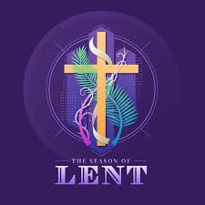

Web site: www.standrewsunitedchurch.com
Ministers: The people of St. Andrews
Supply Minister: Rev. Matthew Penny
Ministry of Music: Lynn and Brian Sloan,
Merna Edison
February 22, 2026
Lent 1

WE GATHER
Welcome & Announcements
Welcome to the first Sunday in Lent —
forty days of returning, remembering, and renewing.
Today we begin in a garden…
and we travel to a wilderness.
We hear stories of temptation —
and we discover that even in failure,
even in testing,
God’s grace is greater.
Wherever you are in your journey of faith,
you are welcome here.

Candle Lighting
We light this candle
as a sign of Christ’s presence among us.
In the garden and in the wilderness,
in temptation and in trust,
God is with us.

Introit - Jesus Remember Me - 148 VU

Acknowledging our Kinship
We gather mindful that long before our churches stood,
Indigenous peoples walked this land in relationship with Creator and creation.
As we begin this Lenten journey,
may we walk gently, truthfully, and humbly with all of God’s creation.

Call To Worship
One: When we wander from God’s path,
All: God calls us home.
One: When we listen to voices that lead us astray,
All: God’s truth remains.
One: When we face wilderness seasons,
All: Christ walks beside us.
One: Let us worship the One whose grace restores us.
All: Let us worship God.

Gathering Hymn - Throughout These Lenten Days and Nights - 108 VU

Prayer of Confession
Faithful God,
In the garden, humanity reached for what was not ours.
In our own lives, we do the same.
We listen to anxious voices.
We chase control.
We doubt your goodness.
Like Adam and Eve,
we hide when we feel exposed.
Like Jesus in the wilderness,
we face temptations —
but we do not always resist.
Forgive us.
When we choose fear over trust,
self-interest over love,
impulse over wisdom —
draw us back.
In silence, we confess before you…
Words of Assurance
Hear the good news:
Where sin increased, grace abounded all the more.
What was broken in the garden
is restored in Christ.
We are not defined by failure.
We are redeemed by love.
In Jesus Christ, we are forgiven.
Thanks be to God.

Words of Assurance

Young at Heart - Two Voices

Hymn - Jesus Bids Us Shine - 585 VU

WE LISTEN FOR GOD’S WORD

Scripture Reading - Genesis 2:15–17; 3:1–7
The story of temptation in the garden.

Matthew 4:1–11
The Temptation of Jesus in the wilderness.
Ministry of Music

Meditation - From Temptation to Trust

Hymn - Jesus, Tempted in the Desert - 115 VU

RESPOND TO GOD’S WORD

Invitation to Offering -
In a world that grasps and hoards, we practice generosity.
We give not out of fear,
but out of trust
that God’s grace is sufficient

Offering Hymn - Grant Us, God, the Grace – 540VU
Grant us, God, the grace of giving,
with a spirit large and free,
that ourselves and all our living
we may offer faithfully.

Offering Prayer
God of abundance and wilderness,
receive our gifts.
Use them to restore what is broken
and to bring hope where trust has been lost.
Amen.

Prayers of Thanksgiving and Concern

The Lord’s Prayer

Closing Hymn - Be Thou My Vision - 642 VU

Commissioning and Benediction
Go into this Lenten season with honesty and courage.
When temptation whispers, remember grace.
When doubt creeps in, remember trust.
When you stumble, remember Christ.
You are held in mercy. You are strengthened by love.
Go in peace.
Amen.

Choral Amen

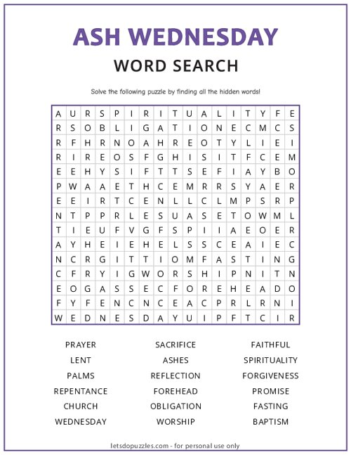
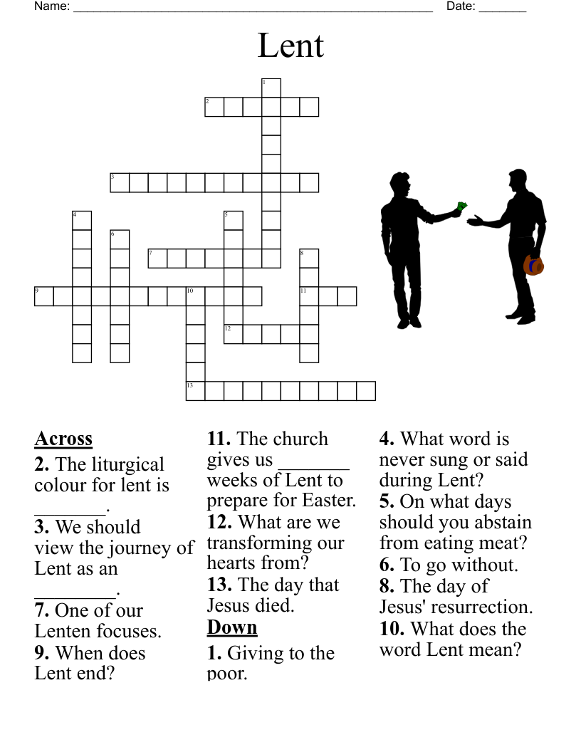

Announcements
Events
February 26th – Board Meeting at 6pm
February 25th – Bible Study at 1pm at NVCC


March 8th is the date of the annual meeting at St. Andrews!


World Day of Prayer 2026 at Central United Church on March 6th at 2pm. All are welcome.


Bible study begins at New Vision on Feb.25th at 1pm. “24 hours that changed the World”

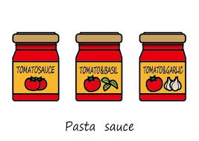
Thank you for your generous support of our 2026 Community Support project – In March we are collecting pasta, sauces, Kraft dinner etc in support of our local food bank. You can rip this off and keep on your fridge as a reminder. (Thanks, Carol for the great idea!!). We are grateful for whatever help you can offer. Full Lists for the year are available in the vestibule on the table. See Belinda if you need more info.



