St. Andrews United Church
and
New Vision Community Church



Ministers: The people of St. Andrews and New Vision
Minister of the People: Rev. Cheryl Bolton
Ministry of Music: Rose Mary Fife
August 2nd, 2026
10th Sunday After Pentecost
Making of a Superhero

WE GATHER

Welcome & Announcements
Candle Lighting
Acknowledging Our Kinship

Call to Worship
Leader: We come from many places, carrying many stories.
Some arrive feeling strong, others weary.
Some come confident, others searching.
Yet God welcomes each one with grace.
All: We gather to worship the God whose love makes ordinary people extraordinary.
Leader: We celebrate the courage to love,
the strength to forgive, the compassion to care,
and the hope that refuses to give up.
All: God calls us to become neighbours, servants, and friends.
Leader: Come, let us worship the One whose power is made perfect in love.
All: Let us worship God.

Gathering Hymn - Come In, Come In and Sit Down - 395 VU

Prayer of Confession
God of mercy, we confess that we often admire heroes more than we imitate them.
We celebrate courage, yet choose comfort.
We praise compassion, yet pass by those in need.
We hope someone else will step forward when love asks something of us.
Like the priest and the Levite, we can become so busy with our own concerns that we fail to notice those who are hurting beside the road.
Forgive us when fear is stronger than kindness.
Forgive us when prejudice keeps us from seeing another as our neighbour.
Forgive us when we forget that every person is created in your image and loved beyond measure.
Fill us again with your Spirit and shape us into followers of Jesus, whose love crosses every barrier and compassion knows no limits. In his holy name we pray.
Amen.

Assurance of Grace
Young at Heart - “Despicable Me”

Hymn - Jesus Bids Us Shine - 585 VU

WE LISTEN FOR GOD’S WORD

Scripture Reading
Luke 10:25–37 -The Samaritan – an unexpected hero.
Ephesians 3:14–21 -God’s power at work within us does more than we imagine.
Ministry of Music

Meditation - Good Samaritan

Hymn - We Are Pilgrims - 595 VU

RESPOND TO GOD’S WORD

Invitation to Offering -
Offering Hymn - What Can I Do? MV 191
What can I do? What can I bring?
What can I say? What can I sing?
I'll sing with joy. I'll say a prayer.
I'll bring my love. I'll do my share."

Offering Prayer

Prayers of Thanksgiving and Concern
The Lord’s Prayer
Closing Hymn - Go Make a Difference 209 MVU
Commissioning and Benediction
Choral Amen

ANNOUNCEMENTS
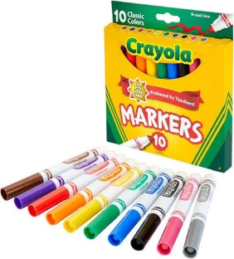
August donations are going to John Wise Public School. They are Needing: dry erase markers, chubby short markers, pencils, rulers and calculators.


St. Andrews United Church will be closed for the month of August and will be joining NVCC. Service will start at 9:45am!!

