St. Andrews
United Church
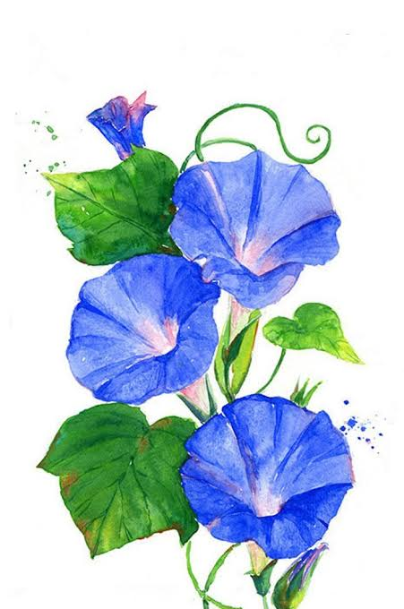

Web site: www.standrewsunitedchurch.com
Ministers: The people of St. Andrews
Minister of the People: Rev. Cheryl Bolton
Ministry of Music: Merna Edison
June 14th, 2026

WE GATHER

Welcome & Announcements
Candle Lighting
One: We light this candle as a sign of God's presence among us.
All: Christ is the light of the world.
One: May this light remind us that God often comes to us in unexpected people and unexpected places.
All: May our hearts be open to welcome Christ in all whom we meet.

Acknowledging Our Kinship
Call to Worship
One: Come, all who seek God's presence.
All: We come with open hearts.
One: Come, all who long to be welcomed and accepted.
All: We come seeking God's embrace.
One: Come, all who are called to welcome friend and stranger alike.
All: We come to learn the way of hospitality.
One: Let us worship the God who welcomes all.
All: Let us worship together.

Gathering Hymn - Jesus Stand Among Us - 396 VU

Prayer of Confession
Loving God,
You welcome us again and again,
yet we confess that we do not always welcome others.
We are quick to judge, slow to listen,
and reluctant to move beyond
what is comfortable and familiar.
We confess the times we have overlooked neighbours,
ignored those who felt alone,
or failed to extend kindness to someone in need.
Forgive us when fear becomes stronger than compassion.
Open our hearts to recognize your image in every person.
Teach us to welcome as Abraham and Sarah welcomed,
with generosity, joy, and trust.
In Christ's name we pray. Amen.

Assurance of Grace
Young at Heart - Welcome Mat
Hymn - Make Me a Channel of Your Peace - 684 VU

WE LISTEN FOR GOD’S WORD
Scripture Reading - Genesis 18: 1-15
Ministry of Music
Meditation - Radical Hospitality
Hymn - I Heard the Voice - 626 VU

WE RESPOND TO GOD’S WORD
Invitation to Offering
Offering Hymn - What Can I Do? MV191
What can I do? What can I bring?
What can I say? What can I sing?
I'll sing with joy. I'll say a prayer.
I'll bring my love. I'll do my share."
Offering Prayer
Prayers of Thanksgiving and Concern
The Lord’s Prayer
Closing Hymn - God Be With You - 422 VU
Commissioning and Benediction
Choral Amen
ANNOUNCEMENTS
June Events
June 17th – Prayer shawl 10:30am.


Please note that the joint Board meeting between SAUC and NVCC on June 16th is cancelled until September.

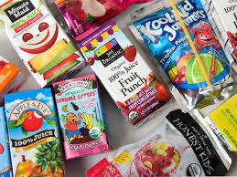
The UCW initiative for June is supporting the Foodbank, they are looking for donations of individual juice boxes (the kind used in children’s lunches. Any kind or flavour is well come.

Board meeting is June 25th at 6pm.

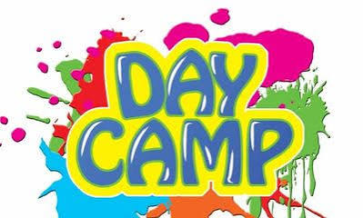
Please share! St. Andrews Growing Youth Summer Camp 2026.
Join us this summer for a fun, safe, affordable camp. Come enjoy games, music, water days, theme days, movies, snacks and more.
Cost is only $110/week per child. (Snacks are included but please bring a lunch)
Week 1- July 6-10th
Week 2- July 13-17
Week 3- July 20-24
Break July 27-31
Week 4- Aug. 3-7
Week 5- Aug. 10-14
Camp hours are 9-3 daily, but before and after care is available for a nominal fee.
Our growing youth Committee and our entire congregation work hard to keep the fees as affordable as possible. Thanks also to the Federal Government for the support of our Youth workers. For more information, or to register your child check our website or call 519-631-4558.

St.Andrews Strawberry Socal, on Friday June 26th 5-6:30pm, tickets are $10. Menu includes chili dogs, strawberry shortcake, reserve tickets by calling 519-631-4558.

