ST. ANDREW’S UNITED CHURCH

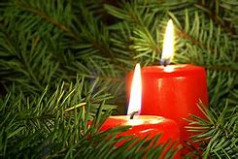

60 West Avenue, St. Thomas
519- 631-4558
e-mail: standrewsucgra@rogers.com
website : www.standrewsunitedchurch.com
Ministers: The people of St. Andrew’s
Pastor: Rev.Cheryl Bolton
Ministry of Music: Brian and Lynn Sloan/Merna Edison
December 3rd, 2022

WE GATHER

Welcome & Announcements
Good morning and welcome to this service of worship, fellowship and fun! This day is a day of preparation. Let us open our hearts, to God and make us ready to receive God.
Repentance, changing our attitudes, our lives, this is just the beginning of our preparations.
God will fill us with Hope and Peace as we become witnesses to God’s love.
May we be faithful servants today and all of our days. AMEN.
Announcements

Acknowledging Our Kinship
As we gather in this time of expectant waiting, we begin by acknowledging the gifts we have already received and thanking Creator God, from whom all blessings flow, for this land on which we live and worship. We acknowledge and give thanks to those who were stewards of the land before our ancestors came and we give thanks to them for the blessing of the sharing of this land. With open hearts we commit ourselves to living into our Advent Peace with love and respect with all our relations.

Advent Candle Lighting - Hamm Family

Peace
Voice 1:
“The wolf shall live with the lamb, the leopard shall lie down with the kid, the calf and the lion will feed together, and a little child shall lead them.” (Isaiah 11:6)
Voice 2:
What does peace look like in the new world?

All:
Peace looks like a flowing river where every living thing has what that they need to flourish.
Peace looks like a place where those who are weak are not afraid of those who are strong.
Peace looks like good conversations around big tables.
Voice 2:
Advent is the beginning of this new world, a better world,
where we can boldly build a good life together.
(Second Advent candle is lit.)
All: Amen.

Gathering Hymn - Hope is a Star - 7 VU - Verse 1&2

ANNOUNCEMENTS
Upcoming Events
December 6-UCW
December 8-Board Meeting at 10am
December 11-“White Gift Service”, 3rd Sunday of Advent
December 18-“Communion Sunday”, 4th Sunday of Advent
December 24- “Christmas Eve Service” 5pm

December Celebrations
December 8- Donna Kerrigan
December 20-Kim Perry
December 22-Pam North
December 23-Erika Broadbear
December 28-Alli Joseph

You can now etransfer givings to St.Andrews. This can be used to make a donation, pay for camp, buy dinner tickets etc. You can do etransfers thru your bank and the email address to use is: statreasurerst@gmail.com. Feel free to ask Rev.Cheryl or Susan or our treasurer Belinda any questions you may have about etransfer.

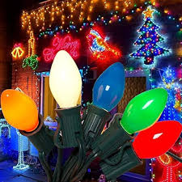Lynn and Brian Sloan would like to invite you to check out their Winter Wonderland display at 70 Mandeville. The lights and blow ups are on every night between 6pm and 9pm! You are even welcome to check out the backyard display.

The UCW and St. Andrews are sponsoring a mom and her 2 daughters for Christmas. The Mom is a size medium and the 2 girls (who are 12 years old) are children’s size 16. Some items on the girl’s list include paint markers, minibrand toys, sketch books, slime kit, tie-dye kit, nail stuff, hair ties, socks, hairbrush and black leggings. Items can be dropped off to the office or bring on a Sunday Morning.

Time to Remember Service – A quiet and reflective advent worship service for those who are grieving: Tuesday December 6th, 2022 7pm at Knox Presbyterian Church, 55 Hincks Street St. Thomas. All welcome.
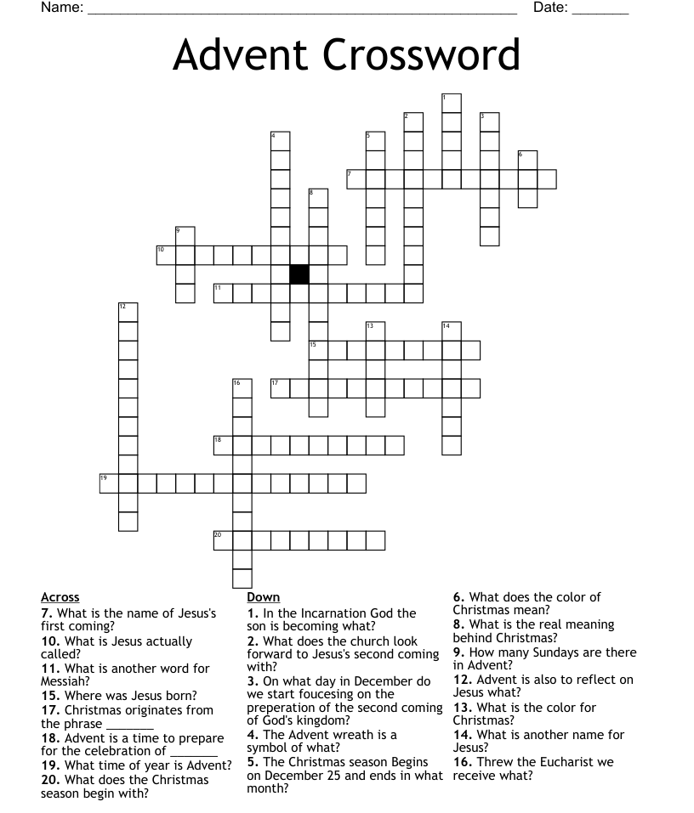
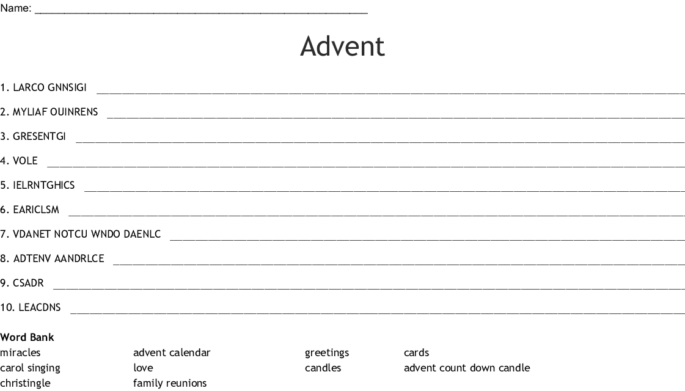

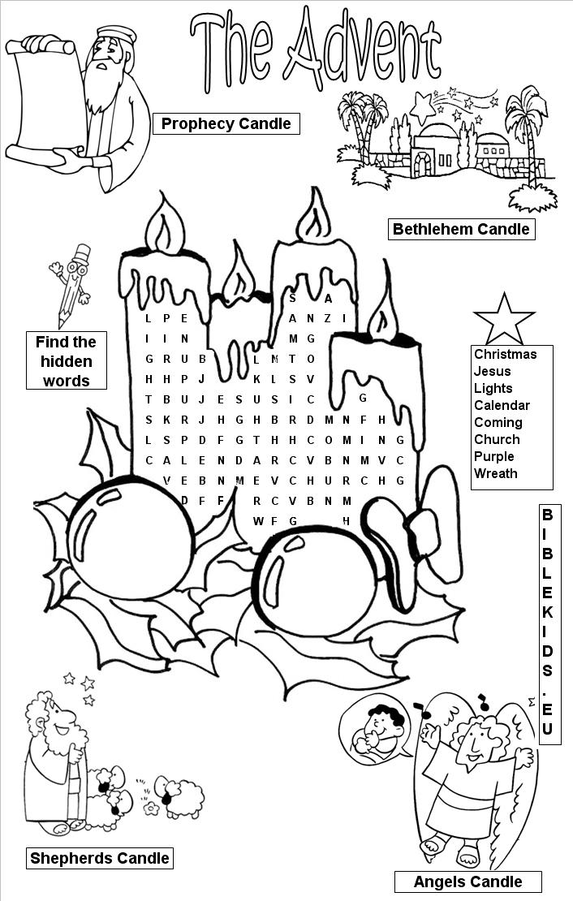

In beloved Memory

The bulletin this morning is dedicated by Ron Laing in memory of his two brothers Floyd – 14 years old and Victor – 8 years old, lost in the woods Mersey Townsite N.S., Dec. 7th, 1941. Remains were found Nov. 19th, 1959.

