St. Andrews United
Church

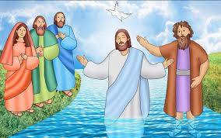

60 West Avenue, St. Thomas 519- 631-4558
e-mail: standrewsucgra@rogers.com
Website: www.standrewsunitedchurch.com
Ministers: The people of St. Andrew’s
Pastor: Rev. Cheryl Bolton
Ministry of Music: Brian and Lynn Sloan/
Merna Edison/Thomas Bee
January 14th 2024
Baptism of Jesus

WE GATHER

Welcome & Announcements
Acknowledging Our Kinship
Candle Lighting

Call To Worship
One: Come in, hearing these words:
All: Do not fear, for I have redeemed you.
One: Come in, knowing these words to be true:
All: I have called you by name, you are mine.
One: Come in, feeling these words in your bones:
All: You are precious in my sight.
One: We come to worship, hearing, knowing, feeling the love and wonder of our God.
Gathering Hymn - A Light is Gleaming - 82

Prayer of Confession
Holy One, on this day when we bear witness to the baptism of Jesus, we hear a story of blessing, of love, of transformation. But over time, this story may have caused us to see ourselves as separated, as special, as those who are better than others. Instead of being inclusive and celebrating who we are and whose we are, baptism has sometimes led us to believe that we are “more special” and “more favoured” than others. For all of these beliefs, we are sorry. May we see the power of transformation that baptism holds and be transformed to see your grace, offered to all of us. Forgive and inspire us, reminding all of us that we are yours. Amen.

Words of Assurance
Reflection - An Extraordinary Gift
Hymn - We Praise You, O God - 218 VU

We Listen For God’s Word
Scripture Reading - Isaiah 43: 1-7, Luke 3: 15-17, 21-22
Meditation - Well Pleased
Hymn - I was there to Hear Your Borning Cry - 644 VU

RESPOND TO GOD’S WORD

Invitation to Offering -
Offering Hymn - For the Gift of Creation - 538 VU
For the gift of creation, the gift of your love, and the gift of the Spirit by which we live, we thank you and give you the fruit of our Hands. May your grace be proclaimed by the gifts that we give.

Offering Prayer
Gracious God, bless what we offer this day. These
gifts, though ordinary, are given in response to your
extraordinary love for us. Through your Spirit, may
these gifts be transformed to reveal your
extraordinary love and may your love be shared in all
that we say and do. Amen.

Prayers of Thanksgiving and Concern
The Lord’s Prayer
Closing Hymn - Spirit, Spirit of Gentleness - 375 VU
Commissioning and Benediction

Announcements

Upcoming
Jan. 17 – Walking Wednesday - 10am
Jan.17- Prayer Shawl-10:30am

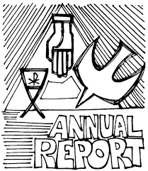
Annual Reports are due by January 28 2024. You can email them into the office or drop them off. Emailed reports can be sent to standrewsucgra@rogers.com.

